I Love Acid wins Best Club Event at DJ Mag’s ‘Best of British’ awards 2019
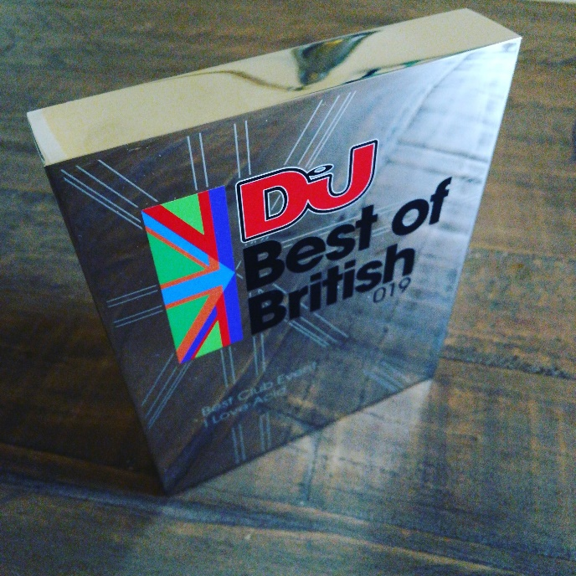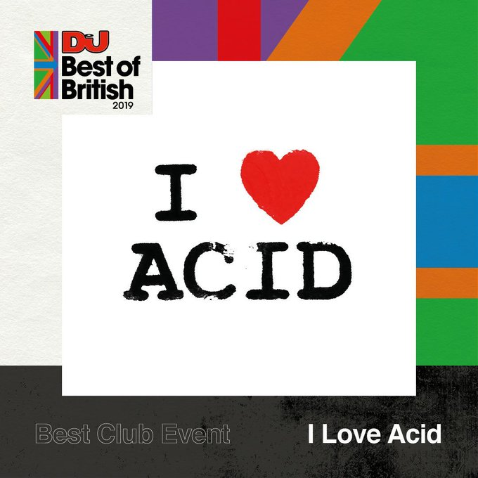
Founded by Posthuman and Luke Vibert in 2007, with approaching 150 parties across the UK and Europe, I Love Acid is a clubnight dedicated to all things 303. Not a retrospective night – but focused on both new and classic acid house, techno, rave, electro and anything else Roland’s notorious magic silver box has touched. We welcome regular crowds that are diverse in age, race, gender and sexuality – and we operate with an eye on being a safe space for clubbers & DJs alike.
Before Covid-19 closed down clubland for 2020, I Love Acid held residencies in Pickle Factory (London), Gorilla (Manchester), 24 Kitchen St (Liverpool) with parties in Chicago, Barcelona, Leeds, Plymouth, Brighton, Glasgow booked in.
In the past, before 2020, I Love Acid has touched down across the UK from Bristol to Edinburgh, Belfast to Sheffield. In Europe; Barcelona to Antwerp, Lille to Berlin, and a decade of annual parties on the island of Malta. We hosted a regular stage takeover at Bangface Weekend, and Bloc Weekend (including closing the Sunday night at the very last ever festival back in 2016)
Past guests include everyone from legends like Hardfloor, DJ Pierre, A Guy Called Gerald, Justin Robertson, and Leftfield, to current luminaries like Ben Sims, object blue, Lauren Flax, Benjamin Damage, Josh Caffe, and Wes Baggaley, plus new artists like Kerrie, Granary 12, and Beyun - with regular appearances from DMX Krew, Ceephax, and Nightwave, joining residents Jon Dasilva, Posthuman, Placid, and Luke Vibert.
An accompanying vinyl-only label has seen over 20 records in a row sell out (often in less than an hour). I Love Acid resident DJ Placid also runs the “We’re Going Deep” group, a 12,000-strong online community of vinyl record traders.
Instagram: http://www.instagram.com/i.love.acid
Facebook: http://www.facebook.com/iheartacid
Soundcloud: http://www.soundcloud.com/iloveacid
Discogs: https://www.discogs.com/label/672661-I-Love-Acid
Posthuman on Twitter: http://www.twitter.com/posthuman

Press links:

DJ Magazine, 2019 “Best of British” Awards:
https://djmag.com/longreads/here-are-all-dj-mag-best-british-awards-2019-winners

Hyponik “12 Years of I Love Acid” interview:
https://hyponik.com/features/posthuman-reflect-on-12-years-of-i-love-acid-parties

“I Love Acid” Label focus & interview on Rhythm Travels:
http://rhythmtravels.com/music/label-focus-i-love-acid
Solid Steel “30 Years of Acid” show:
https://soundcloud.com/ninja-tune/solid-steel-radio-show-11-4-1/

I Love Acid interview & mix from Luke Vibert
https://www.theransomnote.com/music/mixes/rn-line-out-luke-vibert-live-mix/

Boiler Room Upfront Mix:
https://soundcloud.com/platform/upfront-049-i-love-acid

